Colliding BEC - binary collision simulation
Scope of simulation
A classical simulation of BEC collision carried out in ANU He* BEC lab is carried out numerically. The model assumes a classical binary, elastic, s-wave scattering of pairs of particles from two separate condensate “sources”. The sources have identical momentum distribution calculated from the Thomas-Fermi approximation of BEC spatial distribution. For simplicity, the analytical TF momentum distribution is approximated by a 3D Gaussian with equal HWHM (1.99/R_i). The model further assumes that momenta of the collision pairs are independent, except that they cannot both be from the same source. Source velocity in the centre of mass frame (½ collision v) has been set to hbar*k/m_He, which is close to experiment.
The simulation parameters relevant to our experiment are the condensate population, the trap frequencies, the quantum efficiency of detector, and the number of scattered atoms detected.
Comparison of the width of scattering shell is made to the second order correlation length of back-to-back momentum pairs (g^2(BB)).

Methods
From the Thomas-Fermi approximation, the momentum widths of the sources are determined. Collision pairs are repeatedly generated (random selection of a collision pair from source p distribution → elastic, s-wave scattering) and each particle randomly filtered to simulate non-ideal detector efficiency, until a set number of scattered atoms are met. When the simulation has run for a sufficient number of times, the collated set of scattered atoms in momentum space show the familiar s-wave scattering halo from experiments.

Results
Summary for a weak {48,180,180}Hz, and strong trap {50,500,500}Hz*
* Scattering halo
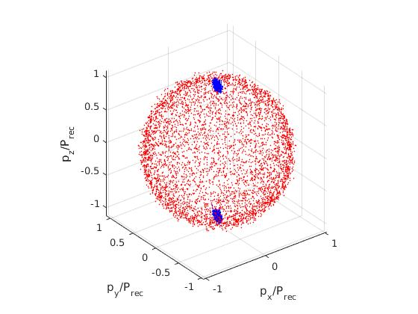 | 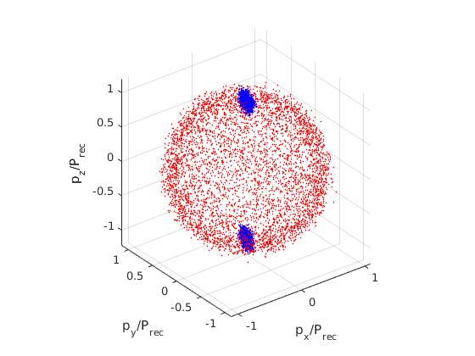

* halo momentum width
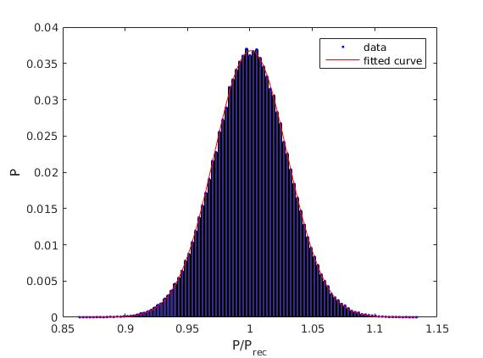 | 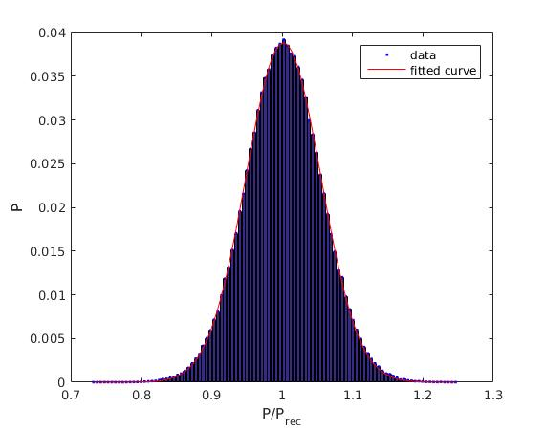

* g2_BB

* Table of results
p_width_weak

